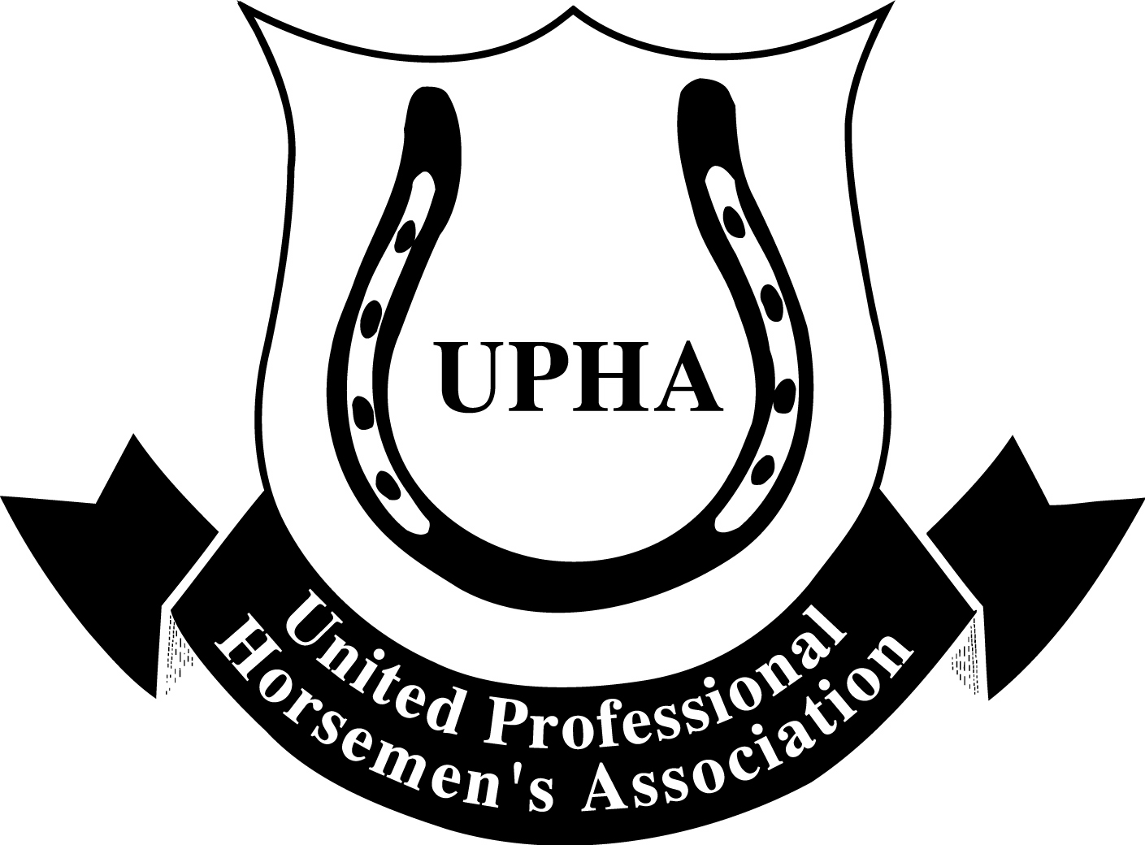
MISSOURI STATE FAIR SOCIETY HORSE SHOW
HOSTED BY UPHA CHAPTER 5
SPONSORSHIP FORM

_____ Diamond Evening Session Sponsor $1,500.00

Sponsor will receive a Championship or Stake class presented in your name, a ring-side banner
and recognition from center ring during your sponsored evening session.

_____ Platinum Day Session Sponsor $1,000.00

Sponsor will receive a Championship or Stake class presented in your name, a ring-side banner
and recognition from center ring during your sponsored matinee session.

_____ Gold Sponsor $500.00

Sponsor will receive a UPHA Classics class or a stake class presented in your name and a ring-side
banner.

_____ Silver Sponsor $250.00

Sponsor will receive a Stake Class presented in your name.

_____ Bronze Sponsor $150.00

Sponsor will receive a performance class or Academy State Championship class presented in your name.

_____ Trophy Sponsor $50.00 ______ Ribbon Sponsor $35.00

_____ Friends of Missouri State Fair Society Horse Show – Any Amount

All donors receive recognition on web site and on social media

Make checks payable to UPHA Chapter 5
c/o Chris Willis
19605 E 11th Terrance, North
Independence, MO 64056

Sponsor Name___________________________________________________

Address ____________________________________________________

____________________________________________________

Email ________________________________ Class preference _________________________________

Check Enclosed_______________ Credit Card#______________________________________________
Expiration date____________________ CVC #_______________

